# Amazon CloudFront

## What is CloudFront?

* Amazon CloudFront is a content delivery network (CDN) offered by AWS.
* CDN provides globally-distributed network of proxy servers which cache content, i.e., web videos or other bulky media, more locally to consumers, thus improving access speed for downloading the content.
* CloudFront's Web distribution support "**Progressive**" download i.e., data from S3 is cached and then streamed without disruptions. Due to that, the user cannot move front or back in the video i.e., the video is processed bit by bit.
* CloudFront's Web distribution support "**Streaming**" allows users to directly watch without any download. Due to that, the user can move front or back in the video, the latency is based on the size of the file and the customer Internet bandwidth.

## Steps

### Create Public S3 Bucket

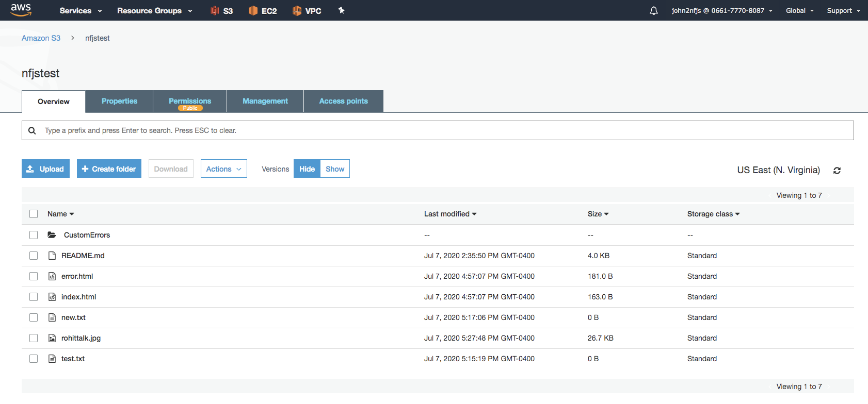

Upload files to S3

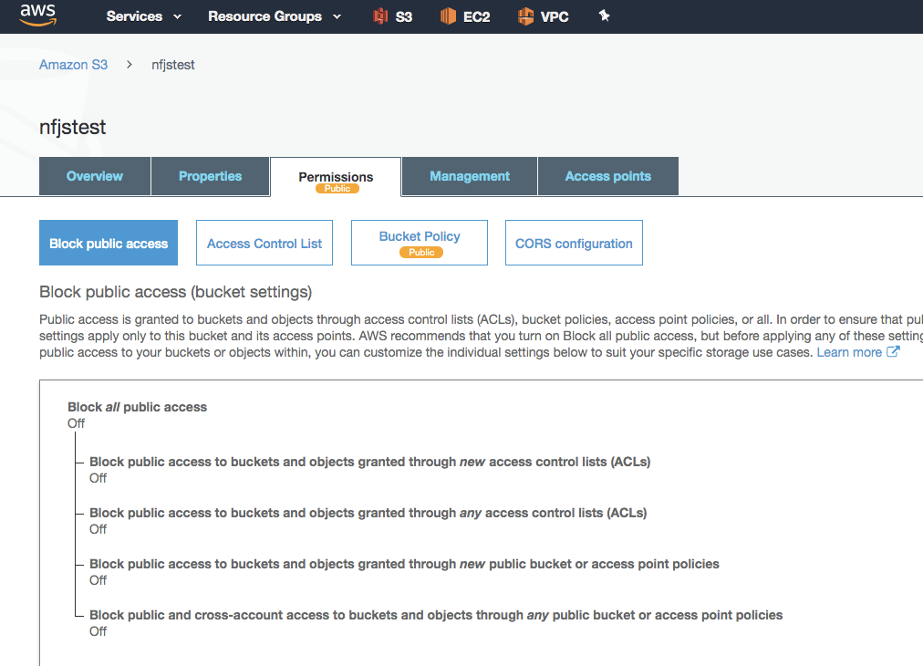

Create custom error pages: CustomErrors/

Copy files from the directory files directory

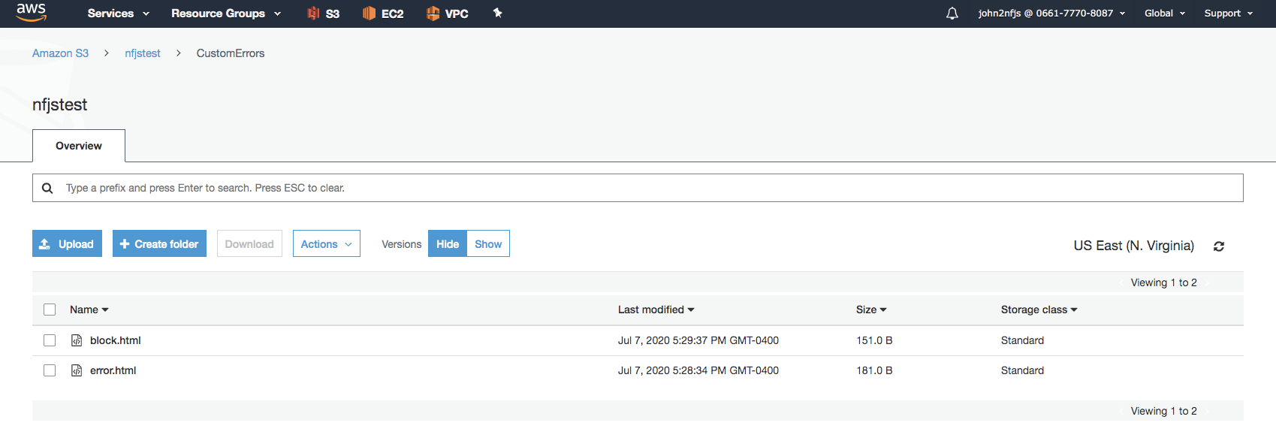

### CloudFront Distribution

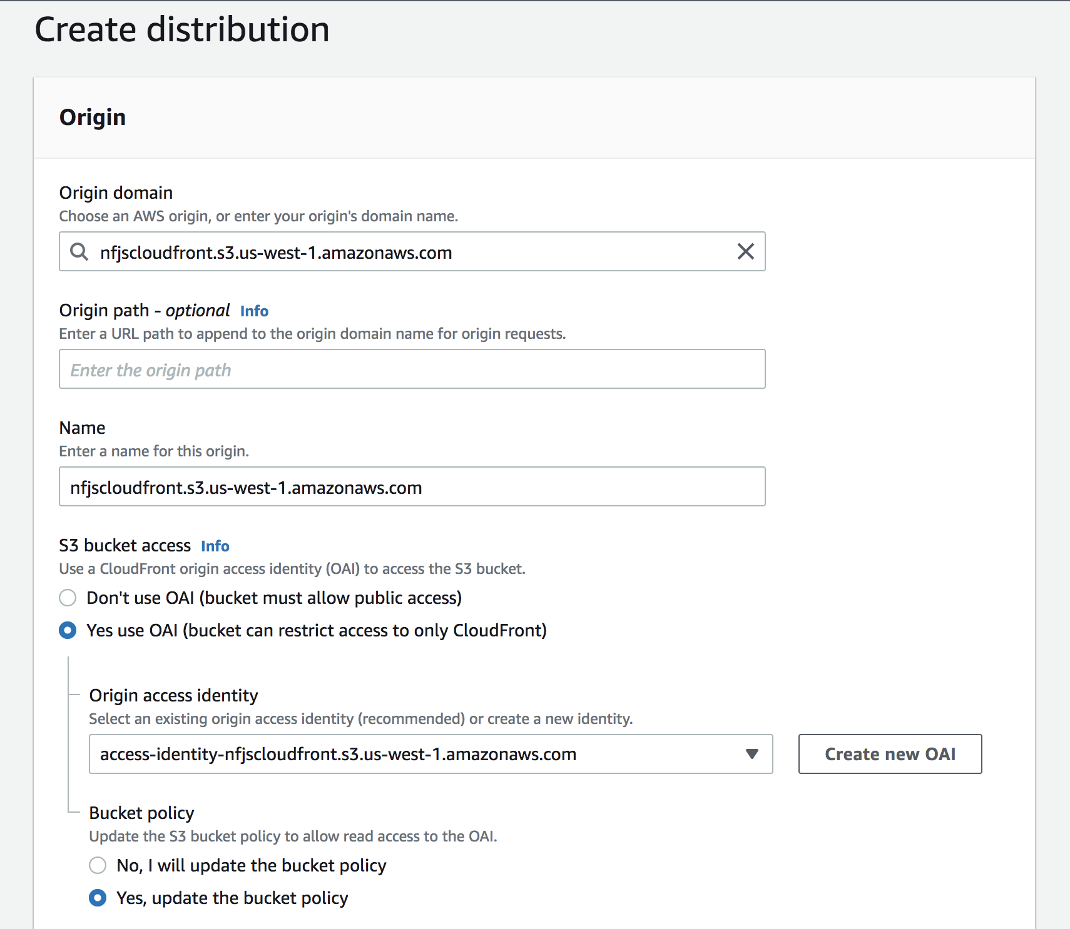

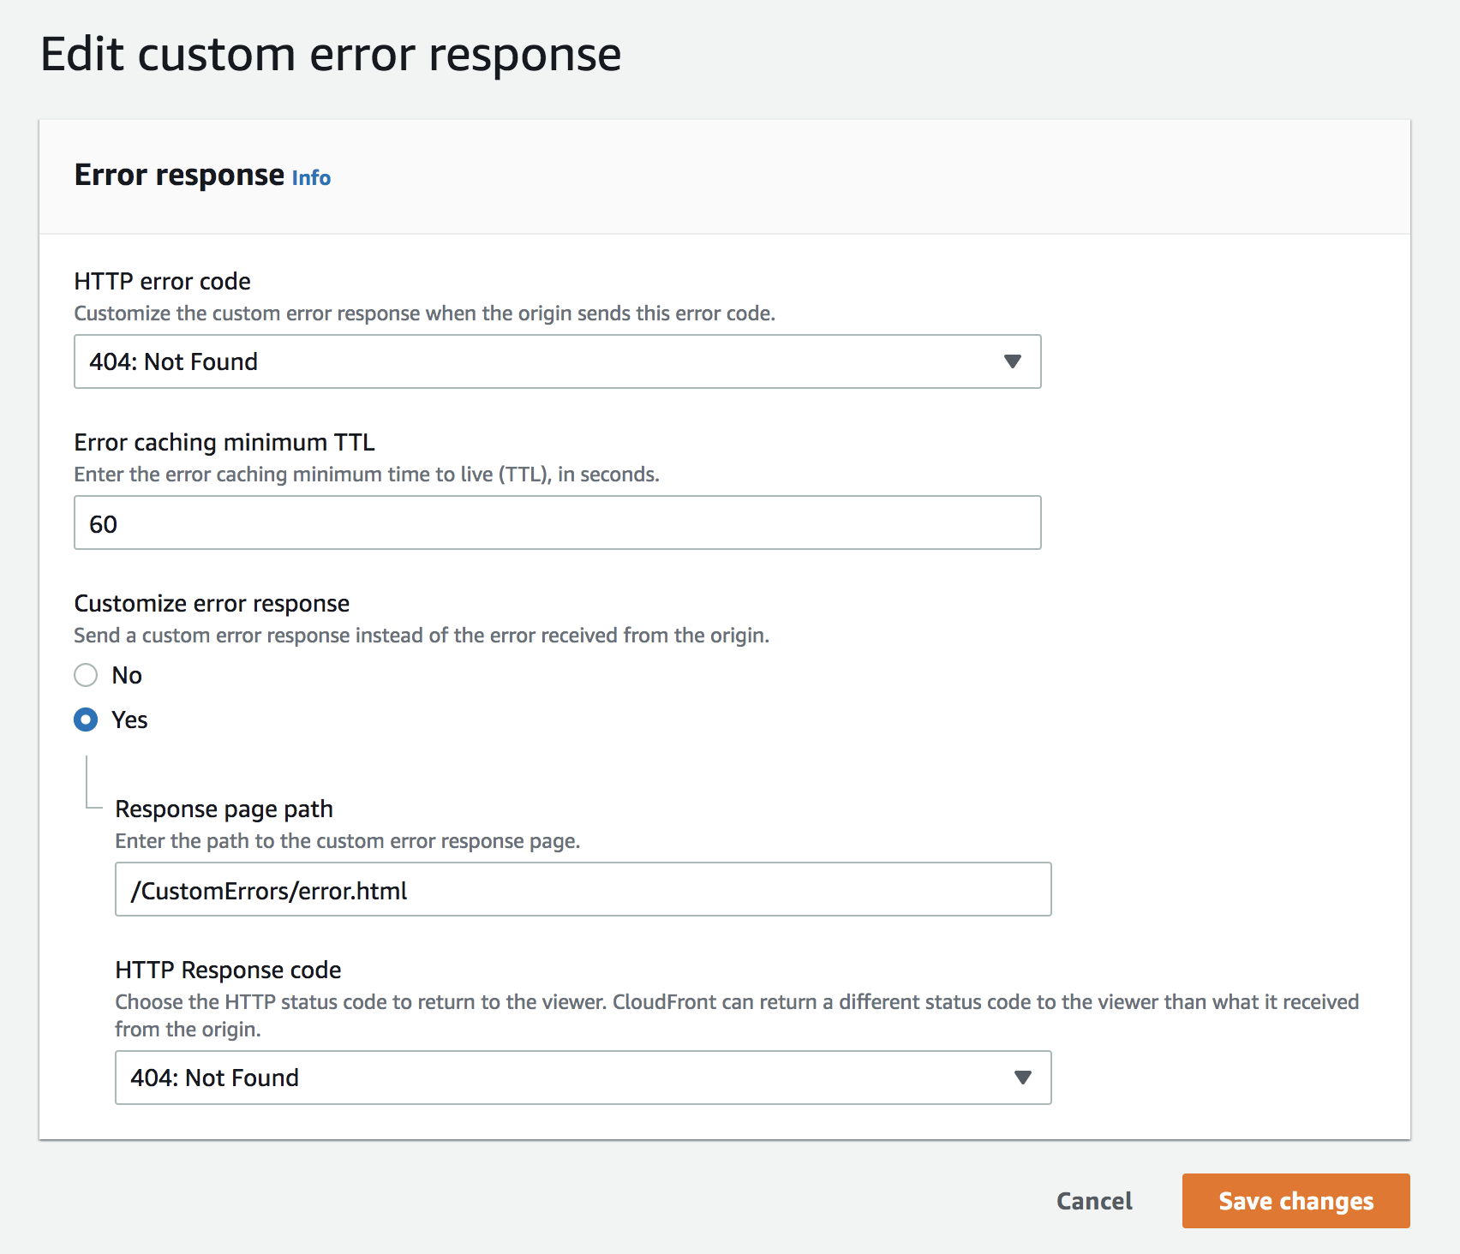

### Define Origins

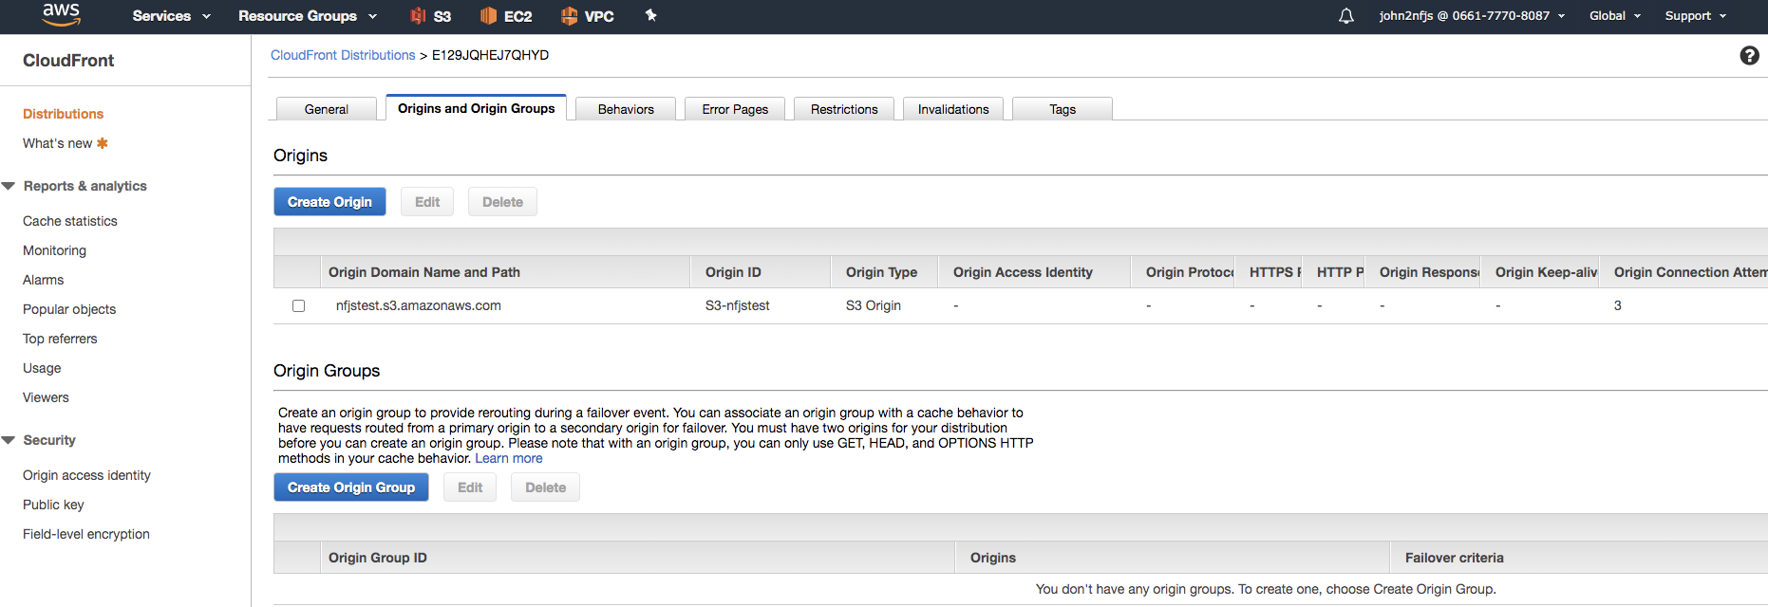

### Geo Restriction

